***Automation Testing***

1. Navigate to the Project “R” Drive and download the older version of Firefox 57.04

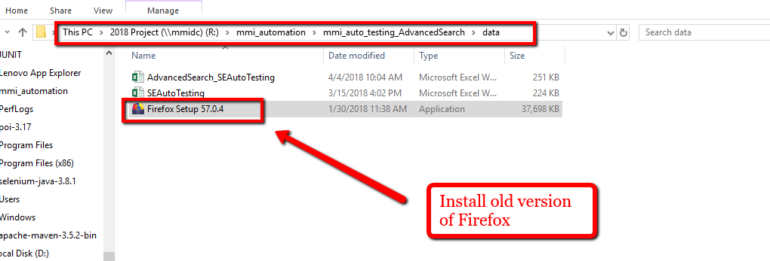

1. Click the Firefox set icon.

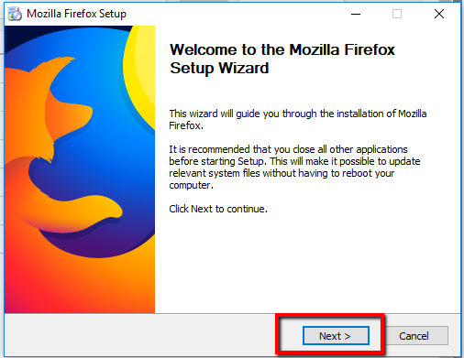

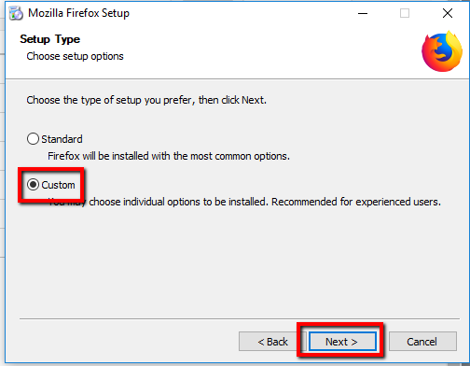

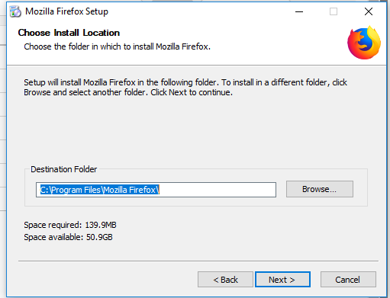

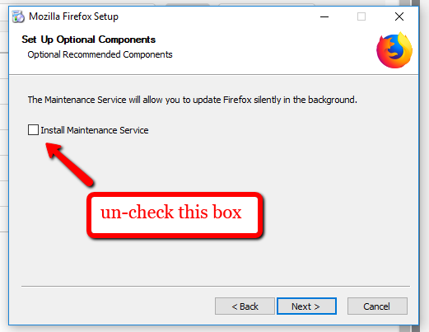

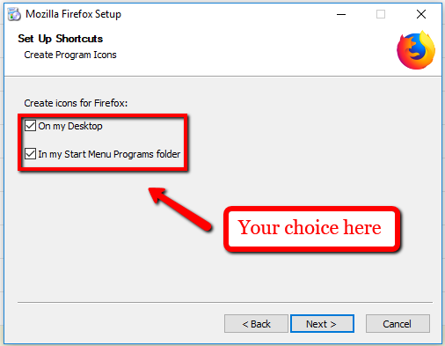

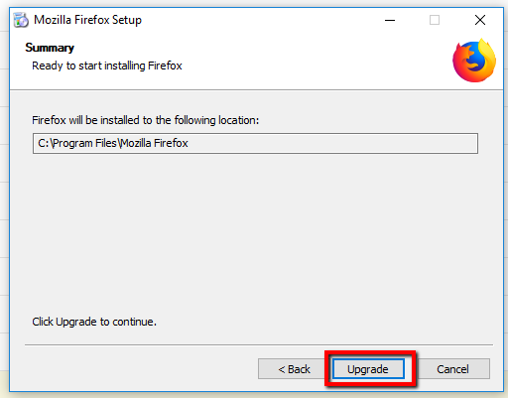

After the download is complete, Go to the Settings/options menu in Firefox.

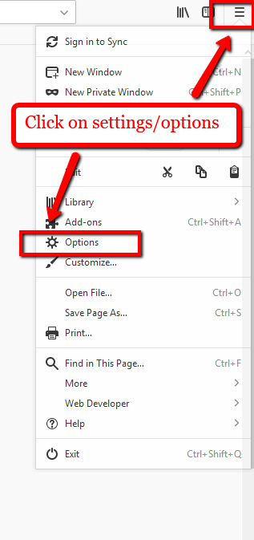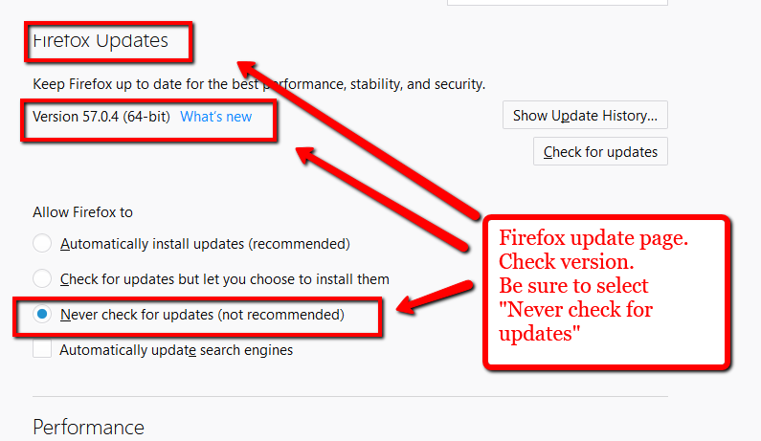

Once you have selected the option to never update, close the browser and reopen it. The browser should be ready to go. Double check the version once or twice to be sure the computer has not automatically updated the version. If the version is below 58.1, then it will be ok to run the executable files. *Newer version prevent automated Password enter which will stop the automation program.*